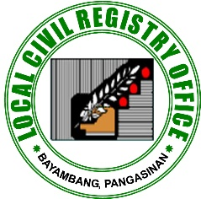Republic of the Philippines

Civil Registry Form No. 1A

(Birth - Available)

Province of Pangasinan

**MUNICIPALITY OF BAYAMBANG**

**LOCAL CIVIL REGISTRY OFFICE**

***TO WHOM IT MAY CONCERN:***

We certify that among others the following facts of birth appear in our Register of Births on page ________ book number ________.

|  |  |  |
| --- | --- | --- |
| Registry number | : |  |
| Date of registration | : |  |
| Name of child | : |  |
| Sex | : |  |
| Date of birth | : |  |
| Place of birth | : |  |
| Name of Mother | : |  |
| Citizenship of Mother | : |  |
| Name of Father | : |  |
| Citizenship of Father | : |  |
| Date of Marriage | : |  |
| Place of marriage of parents | : |  |

This certification is issued to upon his/her request.

*Municipal Civil Registrar*

*Verified by:*

|  |  |  |  |
| --- | --- | --- | --- |
| Amount Paid | : |  | |
| O.R. Number | : |  | |
| Date Paid | : |  | |
|  |  |  |  |

**Note:** A mark, erasure or alteration of any entry invalidates this certification.